Chapter 16, Problem 62.

Using Fig. 16.85, design a problem to help other students to better understand solving for node voltages by working in the s-domain.
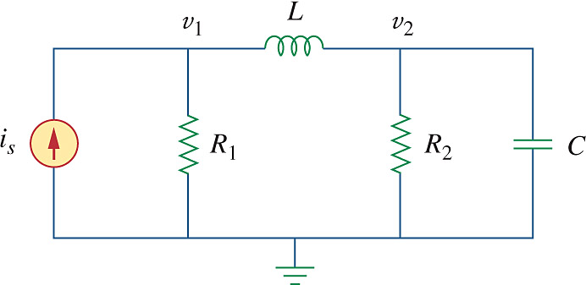

Figure 16.85
For Prob. 16.62.

